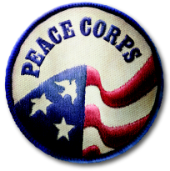

STUDENT INTEREST FORM

Background information:

Name: __________________________________________________ Date: ______________________

Classification: _________________________________________ Department: ____________________

School and/or Organization: _____________________________________________________________

School Address: _______________________________________________________________________

_____________________________________________________________________________________

Phone: _________________________________ Mobile: _____________________________________

Fax: __________________________________ Email: ______________________________________

Permanent Home Address: ______________________________________________________________

_____________________________________________________________________________________

Phone: _________________________________ Mobile: _____________________________________

Fax: __________________________________ Email: ______________________________________

Academic and/or Extracurricular Accomplishments: ___________________________________________

_____________________________________________________________________________________

_____________________________________________________________________________________

Training and experience in a specific work sector:
Please check beside the sector in which you would like to focus as a participant in the Peace Corps Prep Program:

Education __________
Health __________
Youth in Development __________
Community Economic Development __________
Agriculture __________
Environment __________

Foreign language skills:

Please list languages you speak and indicate your current level of fluency, e.g., beginner, intermediate, advanced, fluent, etc.

Additional Comments or Information:

Please share additional information that you would like for us to know about you and your interest in the Peace Corps Prep Program at UAPB.

______________________________________ _________________
Student Signature Date

